
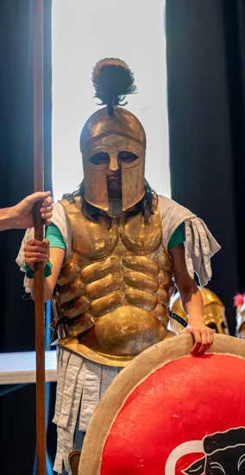
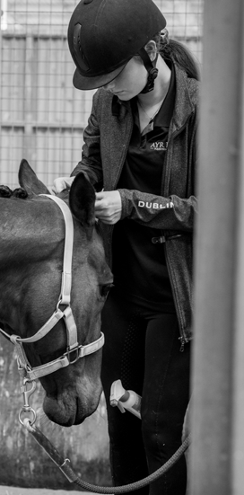
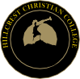






COMMUNITY REPORT
www.cresteducation.vic.edu.au
2023

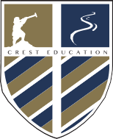

BOARD CHAIR’S REPORT
CONTENTS
- Board Chair’s Report
- Executive Principal
4/5 Head of College Rivercrest
6/7 Head of College Hillcrest
- VCE Results & Tertiary Placements
- Attendance & Ayr Hill Equestrian Centre
- Finance & Development
- Satisfaction Surveys & Teacher Qualifications
ith this report, we celebrate another year in our life at CREST Education. Along with my fellow Directors, I am very blessed to be a part of what we believe is
W
essential for the continued success of our communities, state and country - the education of our children and young people.

With great pride, we share our 2023 Annual Report, which provides an illustrative sampling of the incredible accomplishments that happen daily in our CREST colleges. Our report outlines quantifiable success in key areas of enrolment growth and strong financial results, which are a result of a shared school community commitment to high quality Christian education.
We are also excited by the commencement of construction works on the CREST Senior Learning precinct, an exciting project that will broaden and enhance pathway opportunities for all Hillcrest and Rivercrest senior students. A successful strategic review was also implemented to better align our leadership structures to support a more unified and efficient CREST organisation.
We pray that God will continue to lead and bless CREST as we embrace the challenges and opportunities that lie ahead. Our schools are places of wonder and joy, accepting of all, where every child has a chance to realise their unique God given potential.

Amelia Buchanan - CREST Board Chair

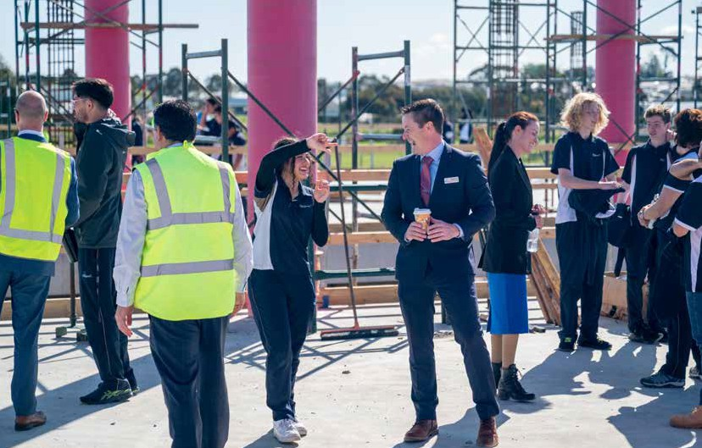

2 www.cresteducation.vic.edu.au

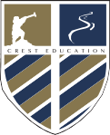
EXECUTIVE PRINCIPAL’S STATEMENT
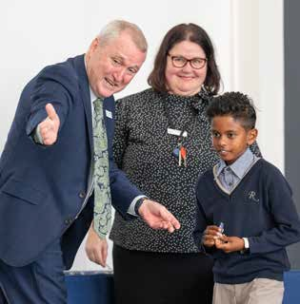
he grateful peace of God does not come from comparison, success, peer acceptance or piety, but only on Christ and what he has done for us. Therefore,
T
while we have incredible blessings to thank God for, they are
nothing compared to our salvation in Christ.

We have, however, been truly blessed in 2023 and have seen:
- The completion of our CREST Strategic Priorities 2024-2029 document that outlines the strategic plan for our exciting future.
- Enrolments continuing to exceed budgeted expectations, and further high demand for places at both colleges.
- The near completion of the CREST Senior Learning Centre, a
stunning facility for our students and their families.
- The continued strong performances in VCE and VCAL of Hillcrest
Year 12 Students.
- Full authorisation for IB Diploma programmes at Rivercrest.
- A fully staffed school, with continued appointments of leading Christian educators.
- A completed and published CREST Reconciliation Action Plan.
- Strong successes in Sporting and Performing Arts programmes,
and continued excellence in Outdoor Learning.

The Next Strategic Plan
The CREST Strategic Priorities 2024-2029 document was completed and will guide the organisation through the next five years of growth and consolidation. This important document is distilled from the very heart of our school, the CREST Constitution, and sets out the key strategic priorities for the next five years through the four pillars of Instil Faith, Pursue Excellence, Nurture Wellbeing and Serve Community.

An Exciting Future
The Senior Learning Centre project is a significant investment in the future of Hillcrest and Rivercrest, with the aim of providing students with the best pathways to choose from.

Building on the successful growth of Rivercrest over the last
10 years, the Board engaged expert external consultants during 2023 to advise on the next best steps and structures to provide long-term stability as we transition out of our ‘growth’ phase and into our ‘maturation’ phase. Key benefits of this revised structure included:
- Streamlining processes and systems,
- Ensuring best-practice teaching and learning approaches,
- Alignment in wellbeing operations and co-curricular opportunities,
- The appointment of key specialists in each role who are
equipped and experienced to lead each area in excellence,
- Minimising the need to ‘double-up’ on expenditures, keeping our
school fees as affordable as possible for our families.

To enable these benefits the CREST Leadership Team saw the
following changes:
- Deputy Principal Campus Operations – Overseeing teaching and College operations across CREST (including the Early Learning Centres)

- Deputy Principal Staff and Students – Overseeing student wellbeing, student services, staff performance and growth, and co-curricular programmes.
- Deputy Principal Teaching and Learning – Driving excellence in Teaching and Learning across all of CREST.
- Head of People, Strategy and Culture to best support our staff.
- Head of Senior Secondary Campus – Driving excellence in the
Senior Learning Centre.
- Head of Early Learning across CREST – Ensuring consistent best-
practice for our youngest learners.

The new CREST Organisational Structure is a wonderfully crafted example of a “one school” model that is also able to successfully sustain unique “sub-schools”, or in our case Campuses. It enables consistent standards of excellence in operations, teaching and learning, and staff and student wellbeing while allowing for individual differences among our six campuses.

Board Changes
Over the last fifteen years we have been greatly blessed by the wonderful service to CREST of Mrs Melinda Izvekov. Serving as a member of the CREST board, including five years as Board Chair, Melinda has given greatly to our organisation. Her leadership of the board has been characterised by a deep commitment to the wellbeing of all in the organisation, and her faithfulness to God’s calling on her life has been an inspiration to many.

As she now steps down from being a board member, we pray every blessing upon Melinda and her family and thank her for such dedicated service to CREST.

Mr Brendan Kelly - Executive Principal

3

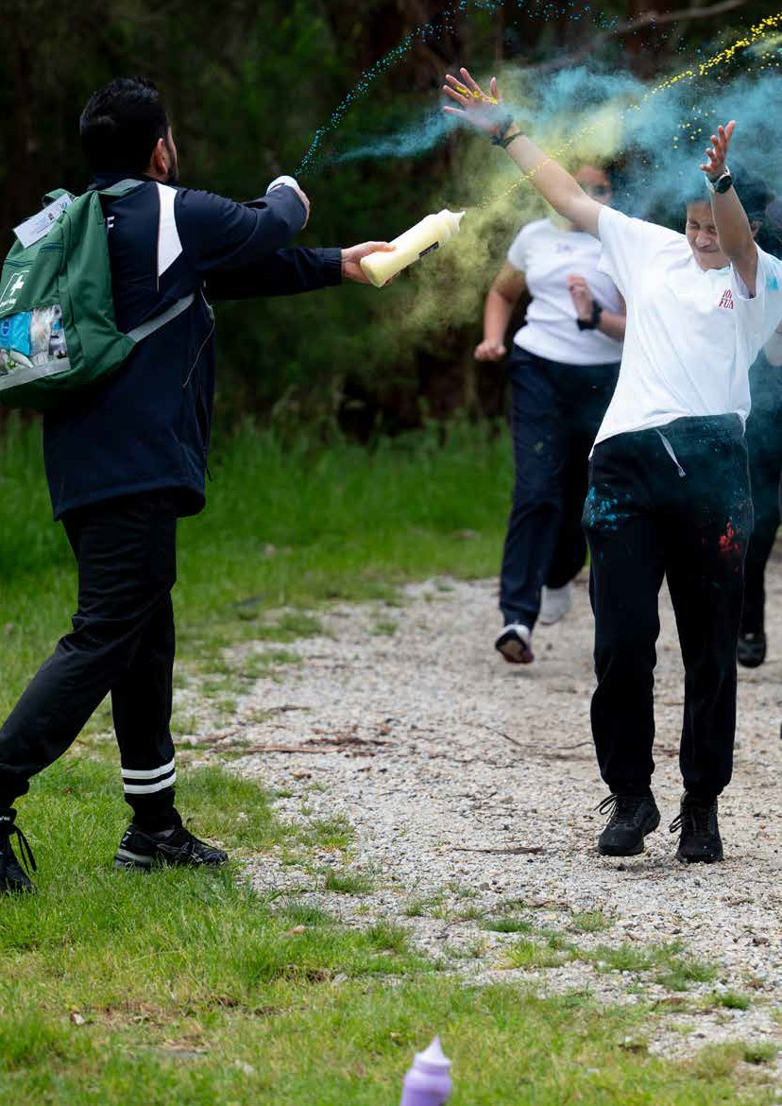


RIVERCREST
THE THEME FOR RIVERCREST IN 2023 WAS ‘YEAR OF GRATEFULNESS’.

ivercrest realised its vision, in 2023, to become one of a select few IB World Continuum Schools, with the successful authorisation of

2023 explore how Sustainable practices improve a community’s way of life. Year 5 students investigated a range of inquiries and took meaningful action in response to their research. One student chose to investigate how migrant families were unable to access free medical care; following her research, she took action by meeting with a local Government MP and developed an official petition, which led to a proposal to make health care available to non- residents being brought to Parliament!

Our commitment to belonging and community continued to be expressed through the ever-popular Community Picnic, Christmas Picnic, Mothers’ and Fathers’ Day events, the Learning Celebrations, Exhibitions and Showcase events, and so many more year-level based activities which reflected our shared commitment to connection, inclusion and mutual support. We are grateful to all the families who stepped up as members of our Community Association and Year Level Representative teams to help see these opportunities come to life.

We are grateful to God for our first international trip since COVID, with our inaugural French Language Tour to New Caledonia. Students from Years 9 and 10 spent several weeks being immersed in French language and had the blessing of engaging in an exciting cultural exchange. We are looking forward to the opportunity to expand our international trips programme in the future!

We were grateful for the opportunity to join our Hillcrest campus in the Southern Independent Schools competition towards the conclusion of 2023, and are excited about the high level of competition this will provide for Rivercrest students in the years to come. Rivercrest and Hillcrest competed together in a joint Annual Swimming Tryouts and are planning to send our first CREST Swim Team to compete in the future. The CREST Netball Academy won the Casey Cup Tournament in 2023 and our CREST Basketball Academy participated in the Australian Basketball Championships in the Gold Coast for this first time, and we are delighted to celebrate the success of our CREST Girls Team, who won gold in their competition!
R
the IB Diploma Programme for students in Year 11 and 12. Being an IB World Continuum School means that students can complete three programmes of the IB at the College – the Primary Years programme, Middle Years programme and IB Diploma programme, in addition to the VCE and VCE pathways available for students in the Senior Learning Centre.

The continued growth of the Middle Years campus was a joy to behold, with new facilities being provided to enhance student learning with the official opening of the Rivercrest Centre for the Arts, Sciences and Design, which included a state-of-the-art facility with two double-size Science labs, a Design Technology Hub and Visual Arts studios. In addition, the opening of the Middle Years Gym and three outdoor multi- purpose courts improved opportunities for students in co-curricular and sport.

Middle Years students also took to the stage in strength as part of the CREST Secondary Production, Hairspray, with two casts of performers providing opportunities for Rivercrest students to take on lead roles within this wonderful musical extravaganza. Rivercrest Primary’s Production, On Safari, was a breathtaking expression of creativity, musicality and performing prowess, with students from Years Two to Four showcasing their skills with confidence.

Learner agency and student voice are at the core of our IB programmes, and this was beautifully expressed through the inaugural Middle Years Personal Project, where students in Year 10 were mentored in pursuing the development of a skill or product related to an area of passion. Some Year 10 students explored the design of hybrid car engines, whereas others learned how to bake wedding cakes and created their own micro-business; one learned the skills of portraiture and painted a beautiful piece representing her father, which was unveiled at the Launch Event – a truly special and memorable occasion.

This experience builds wonderfully upon our annual Primary Years Programme Exhibition, which in

4 www.cresteducation.vic.edu.au


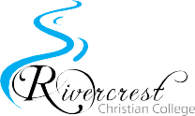


Rivercrest NAPLAN Data

Rivercrest students have again achieved excellent results in NAPLAN again in 2023. It is always great to reflect on the positive impact our teachers have across Years 3 to 9, which come through clearly in the College’s data.

Year 3
Our students showed outstanding results especially in the writing domains. 70-95% of the Year 3 cohort achieved either a strong or exceeding level of performance for the tests.
The main areas for improvement for this cohort are:
- Grammar and Punctuation: elements of sentence structure and parts of speech.
- Reading: Interpreting a character’s feelings in an imaginative text.
- Numeracy: Comparing the masses of items on a balance scale using metric units.
- Spelling: Identifies & correcting errors in single and
multisyllabic words.

Year 5
80- 95% of Year 5 students demonstrated a strong or exceeding level of performance across all testing areas, with reading results particularly pleasing.
The main areas for improvement for this cohort are:
- Grammar and Punctuation: Identifying a statements and verb usage.
- Reading: Linking visual features with information in an
informative text.
- Numeracy: Continuing a growing addition pattern.
- Spelling: Correctly spelling 1-syllable uncommon past tense verbs.

Year 7
90-95% of Year 7 students achieved strong or exceeding results across each area of the NAPLAN testing with a large part of the cohort excelling in Grammar and Punctuation, as well as Spelling.
The main areas for improvement for this cohort are:
- Grammar and Punctuation: Identifying sentences with correct pronoun reference.
- Reading: Interpreting the plot of imaginative texts.
- Numeracy: Rounding numbers to a given degree of accuracy.
- Spelling: Correctly spelling 3-syllable words with ‘s’ spelled s, ss, se, ce and c.

Year 9
80-90% of Year 9 students achieved strong or exceeding results
across each area of the NAPLAN testing.
The main areas for improvement for this cohort are:
- Grammar and Punctuation: Identifying proper nouns used in sentences.
- Reading: Analysing the effect of language choices in a persuasive text.
- Numeracy: Calculating the circumference of a circle.
- Spelling: Identifying & correcting errors in multisyllabic words with correct base word elements.

5
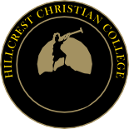

HILLCREST
ur 2023 theme of Gratefulness, and accompanying Bible verse, “Give thanks to the LORD, for he is good. His love
O
endures forever. Give thanks to the God of gods. His love endures forever. Give thanks to the Lord of lords: His love endures forever.” (Psalm 136:1-3 NIV) proved to be a strong reminder throughout the year of God’s goodness to us.

All who had glimpses of the rehearsals for our Hairspray production knew it was likely to be amazing, but little did we know just how incredible this CREST wide musical would be! With two casts of Secondary students from across our two CREST Colleges and four nights of very well attended performances, Hairspray was a highlight of the year.All students involved (cast, backstage crew, orchestra, to name but a few) saw the fruits of their many, many hours of practice fully appreciated by audiences of family, friends and staff. Of special note is our Director of Performing Arts, Mr Peter Thomsen, and his team consisting of Mr Chris Bishop, Mrs Val Roman and many talented volunteers.

Our Primary students also delivered an incredible performance of “Porridge”. Everyone who attended was full of praise for our very talented students, who not only sang perfectly, but also danced and acted with passion and skill. Mrs Kirsty Graham and her team of dedicated staff, including but not limited to Mrs Tarryn Redan, supported our students in a wonderfully successful performance.

This year has seen an incredible growth in student involvement in and success with our VEX Robotics. Students from Primary and Secondary have participated in competitions locally and interstate, and we saw a team head to the USA earlier this year to compete. Special thanks to Mr Paul Lock and Mr Hayden Millstead for their support of our students. VEX has continued to grow in popularity and we now have STEM captains to guide our large numbers of students involved.

Following a relatively slow take up post COVID, we now have a very active and large number of students involved in HPV (Human Powered Vehicles). We are grateful to the many families

who support their children in this co-curricular activity, and acknowledge Mr Bruce Wallace for his ongoing role in coordinating this activity, which has had an incredibly successful year for our students.

Our revised format for the Presentation Ball continued to be a success for all involved. Watching how quickly the Year 11s took to their dance lessons after school was a delight, and an enjoyable night was had by all who attended this special Ball. Every student involved is to be congratulated as is Mrs Kelly Lock and Ms Germaine Moser for their leadership of this event. This year our staff were blessed by spending a day with Professor Guy Claxton from the UK, the founder of Learning Power Approach, as well as our LPA critical friend, Mrs Jann Robinson OAM, a strong Christian educator who was formerly the principal of a large Independent school in Sydney. Teachers have adopted LPA as a new way to build powerful, independent learners, willing and able to pursue their dreams and tackle difficulties calmly, confidently and creatively.

Our student leaders from Primary and Secondary continue to impress all who work with them. They took active roles in our Open Day and ran several events at the College, from the Colour Run to World’s Greatest Shave to dress up days for fund raising.

The Hillcrest Community Association and Primary Parent Representatives group continue to grow in numbers and service to our students and families. The level of parent involvement in supporting our community is a wonderful feature of our College- we are blessed indeed by parents who value the partnership with teaching staff for the learning and wellbeing benefit of their children. Our Community Association generously supported our College with an outdoor movie night, Mother’s Day and Father’s Day stalls and breakfasts, and of course the pancakes after the GAT and ice creams after the Year 12 English exams. Special thanks to Mrs Melani Van der Westhuizen, our Community Development Officer, for the work she does in this area.

We were delighted to engage once again in international tours to support language learners at the College, with our first post-COVID experience involving several students travelling to Japan to visit our sister school in Tokyo. This wonderful experience provided students with the opportunity to be immersed in language and culture, and it is a joy to see our international school partnership continue to grow. We look forward to our planned European study tour, with a visit to our German-speaking sister school in Stuttgart, to take place early in 2024.

Hillcrest students continued to experience great success in sport this year, with eighty students participating in the SIS Cross Country Divisional Competition. We were thrilled to win the Division B Pennant, with outstanding success in U/13, U/14 Open Girls and U/17 Boys and the Senior Shield. In addition, Hillcrest also won eight pennants in SIS Netball, Cricket, Soccer, Volleyball and Handball this year. To top it off, our CREST Basketball Academy participated in the Australian Basketball Championships in the Gold Coast for this first time, and we are delighted to celebrate the

6 www.cresteducation.vic.edu.au

success of our CREST Girls Team, who won gold in their competition!

Hillcrest NAPLAN Data

Hillcrest students have again achieved excellent results in Reading, Writing and Numeracy. These students significantly outperforming the State and statistically similar schools across many of the testing areas.

Year 3 Summary
Our students showed outstanding results across the literacy domains in particular. Over 80% of the Year 3 cohort achieved either a strong or exceeding level of performance for this test.

The main areas for improvement for this cohort are:
- Grammar and Punctuation: identifying verbs and adverbs in compound sentences.
- Reading: identifying the aim of persuasive text.
- Numeracy: questions to gather survey information.
- Spelling: Identifies & corrects errors in 2-syllable
words with ‘-el’.

Year 5 Summary
80- 90% of Year 5 students demonstrated a strong or exceeding level of performance across literacy testing, with writing results particularly pleasing.

The main areas for improvement for this cohort are:

- Grammar and Punctuation: use of quotation marks
for speech.
- Reading: Linking visual features with information in
an informative text.
- Numeracy: Identifying the number sentence needed to solve a division problem.
- Spelling: Correctly spelling 3-syllable words with a medial schwa.

Year 7 Summary
75-90% of Year 7 students achieved strong or exceeding results across each area of the NAPLAN testing with a large part of the cohort excelling in Grammar and Punctuation.

The main areas for improvement for this cohort are:

- Grammar and Punctuation: Identifying a sentence with correct pronoun reference.
- Reading: Interpreting the meaning of vocabulary in an informative text.
- Numeracy: Interpreting a number pattern to identify a missing element.
- Spelling: Correctly spelling 2-syllable words with ‘j’ spelled ‘di’.

Year 9 Summary
75-90% of Year 9 students achieved strong or exceeding
results across each area of the NAPLAN testing.

The main areas for improvement for this cohort are:

- Grammar and Punctuation: Identifies the subject or
modality of sentences.
- Reading: Interpreting the meaning of phrases in informative texts.
- Numeracy: Investigating the effect of an outlier on the mean of grouped data.
- Spelling: Identifying and correcting errors in multisyllabic words with correct base word elements.

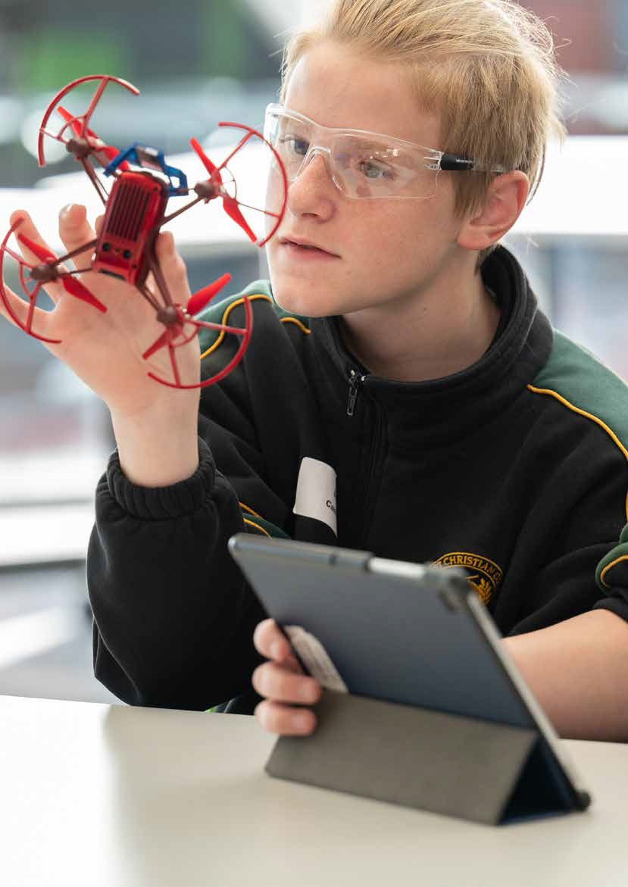

7

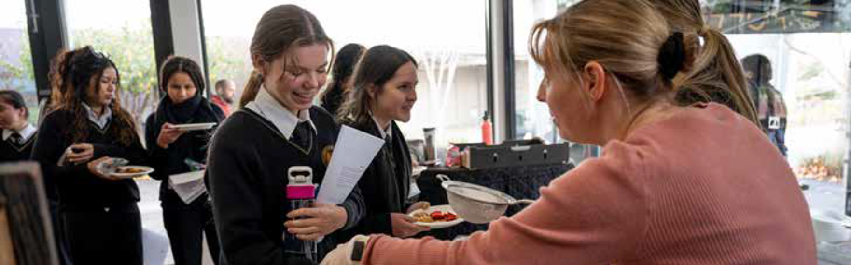
VCE RESULTS & TERTIARY PLACEMENTS

he results of our senior students continue to be consistent every year. Ninety-six students completed Year 12,
T
with twelve students registered as Certificate Only and thirteen students completed the VCE VM. The VCE completion rate was 100%.

Dux & Proxime Accessit
The top ATAR for 2023 was 99.2. The top three students achieved ATAR scores of 99.2, 98.2 and 93.7. Our VCE Dux for 2023 was Sanumi Pallimulla, who achieved an ATAR of 99.2. Our VCE VM Dux was Douglas Fishley. Joel Tan was our VCE Proxime Accessit with an ATAR of 98.2.

There were 71 students who achieved an ATAR. This is less than last year due to more students going unscored and having a smaller overall Year 12 cohort compared to last year. Thirteen students registered as Certificate only.
There were 14 study scores of 40 and over
Students who have graduated from this program have gone on to pursue apprenticeships, traineeships, and further training in fields such as Carpentry, Electrical, I.T, Individual Support, Hairdressing, and the Defence Force.

Tertiary Offers
VTAC Outcomes
Of the 2023 Year 12 Hillcrest cohort, 74 students submitted preferences to VTAC. All 74 were offered a place in the 1st round. 49 students (66%) received an offer for their 1st preference in the first round, 6 received their 2nd preference in the first round, 7 received their 3rd preference in the 1st round. 1 student received their 1st preference offer in the 2nd round, and 2 further students received their 1st preference offer in the 3rd round.

Offered courses in order of popularity:
- Engineering, Nursing, IT/Computer Science, Psychology, Health Science, Science, Sport, Arts, Business & Education.

Other study areas include:
- Animation,Architecture, Biomedical Science, Construction Management, Commerce, Communications, Criminology, Cyber Security, Design, Games Design, Interior Design, International Studies, Laws, Marketing, Paramedicine, Pharmaceutical

(3.7%). This was slightly higher than in 2022.

The highest study scores obtained were:
- 50: Health & Human Development
- 48: Business Management
- 46: Business Management, General Mathematics (2)
- 43: Chemistry
- 42: English
- 41: Chemistry, Psychology, VCD, Economics
- 40: Health and Human Development, General Mathematics, and English Language.
Offers by institution:
- 28.4% RMIT University (25)
- 26.1% Monash University (23)
- 14.7% Deakin University (13)
- 10.2% Swinburne University of Technology (9)
- 4.5% Australian Catholic University (4) Science, and Physiotherapy.
Of the offers made
- 19 were double degrees
- 22 courses including an honours year
- 4.5% Federation University (4)
- 3.4% La Trobe University (3)
- 2.2% Deakin College (2)
- 2.2% Victoria University (2)
- 1.1% The University of Melbourne (1)
- 1.1% Torrens University Australia (1)
- 1.1% SAE Creative Media Institute (1)

There was a significant increase in students who attained an ATAR over 80 compared to 2022.

VCE Vocational Major
2023 was the 1st year that the college offered the VCE Vocational Major certificate, and the fourth year since the initial VCAL program began.There were 13 students who commenced this certificate with 12 successfully completing their VCE VM Certificate.
- 12 were for guaranteed pathway courses (pairs a TAFE and university course together)
- 2 were for professional degrees (these include a year of paid work experience)

Dux & Proxime Accessit
Our VCE Dux for 2023 was Sanumi Pallimulla who achieved an ATAR of
99.2. Our VCE VM Outstanding Effort recipient was Douglas Fishley. Joel Tan
was our Proxime Accessit with an ATAR of 98.2.

8 www.cresteducation.vic.edu.au
10%
31%
58%
ATAR 90+
ATAR 80+
ATAR 70+

HILLCREST RIVERCREST

ttendance rates have traditionally been strong and above the national average. The CREST Colleges use the Synergetic Student Management System
A
Prep | 90.19
1 | 90.81
2 | 91.15
3 | 90.62
4 | 90.98
5 | 91.84
6 | 90.47
7 | 89.43
8 | 89.26
9 | 87.36
10 | 84.36
11 | 86.63
12 | 91.43
Total | 89.3

Year Level
Attendance Rate %
Year Level
Attendance Rate %

for attendance monitoring. Attendance is formally collected twice a day (am/pm) and, there is an expectation that teachers keep a record of attendance, in each of their classes. Absence lists are generated and sent to all appropriate staff.
Prep | 89.31
1 | 90.24
2 | 92.17
3 | 90.79
4 | 91.04
5 | 92.13
6 | 89.97
7 | 92.50
8 | 89.15
9 | 89.97
10 | 88.86
Total | 90.74

The parent or guardian of any student who is absent without appropriate reason or notice, are contacted by the College on that day. If attendance is becoming problematic, interventions are in place to ensure parents are informed of the situation, and that appropriate supports are enacted to minimise further non-attendance.

AYR HILL EQUESTRIAN CENTRE

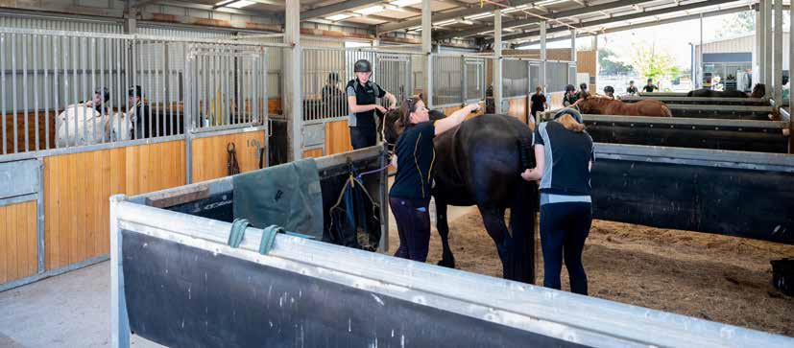


he After School Riding Program continued to thrive in 2023, with 80 students enrolled, 25 of those non-CREST students. The school Holiday program was also extremely popular attracting students both internally and externally. Our Wednesday morning class, offered to Grayling Primary School,
was yet another community link.

Our VET program enrolment numbers increased from 2022, with 77 students from 36 home schools across Victoria. We welcomed Nicole O’Shannessy to the role of 2nd year VET trainer for our Face-to-face students, joining with Gael Sampson (1st Year), Deborah Webb (2nd Year Flexible online) and Emmi Hoefchen (Glenburn campus). We sadly fare welled Gael after many years in various roles. Her contribution to the operating procedures and various programs over the years were instrumental in developing the quality programs offered today.

This year saw the 5-year re-registration audit of the Registered Training Organisation with the VRQA and we are pleased to have successfully met all regulatory requirements to continue to offer the VETiS Equine course.
Our annual Interschool Dressage competition was held in September, and was well attended despite the appalling weather. 30 schools were represented including 4 Hillcrest students who did exceptionally well in the conditions.

Weekend unofficial dressage days were held in September and October and proved popular with the equine community. Staff and students took the opportunity to compete and all did well.

Jill Strafford joined the team of After School/School Holiday coaches, along with Ethan Height and our regular staff, to ensure quality coaching in these programs. I am also thankful that our daily staff consisting of Adele Couty, Deb Whitworth, Sara Williams and Sarah McCluskey supported by Robin Lang, continued to deliver quality and engaging programs for our students. Sarah finished her time with us at the end of the year and we are so thankful for all she contributed to the centre in her 3 years.

Michelle How - Equestrian Centre Manager

9

FINANCE & DEVELOPMENT
CREST Education is a not-for-profit organisation, and we adhere to contemporary commercial business and governance practices to ensure that finances are managed in an effective and efficient manner. All end-of-year surpluses are applied to facility development and/or repayment of borrowings. CREST has also been successful in maintaining school fees at an affordable level that are amongst the best value in this area. The major sources of income and expenditure for 2023 were:

023 was another year where CREST Education invested
2
significantly in its facilities and infrastructure to meet the growing needs of our dynamic school communities. Over the next few years, the development of the Senior Learning precinct will be the main focus of our Capex spend, so 2023 saw the completion of a Gym and Outdoor courts for the Rivercrest Middle Years Campus, whilst the Board also committed funds at Hillcrest to classroom upgrades and completing an upgrade to the Primary play area. The lingering effects of the COVID period has seen sustained cost pressures on projects with work done to mitigate negative effects.

Rivercrest Developments
At the Middle Years Campus, we completed construction on the Gym conversion project providing a much needed indoor sports learning space. The completion of an artificial grass
outdoor playing fields has delivered capacity to play either basketball, netball, tennis and soccer on each of the three courts with a beach volleyball court added alongside.

Hillcrest Developments
Significant landscape works to upgrade the Primary playground were completed to deliver an enhanced outdoor play and learning area. Renovations were also completed on 2 secondary classrooms and these upgrades significantly improved their amenity and suitability.

Masterplanning
The commencement of planning for the Crest Senior Learning precinct, has brought more focus on the masterplan for the balance of the site, and the Board continues to strategically explore a range of opportunities.


income sources
58%
39%
1%
2%
Government Grants
School Fees & Levies
Capital Grants
Other
expenditure focus
70%
9%
8%
4%
Employee Beneﬁts
Curriculum
Depreciation
Building & Maintenance
3%
3%
2%
1%
Ofﬁce
Other
Transportation
Finance

10 www.cresteducation.vic.edu.au

TEACHER

QUALIFICATIONS
The Victorian Institute of Teaching (VIT) monitors the registration of teachers throughout Victoria, ensuring all teachers meet the standards of professional teaching practice within three domains of knowledge, practice and engagement.
Besides the formal tertiary qualifications that are necessary for a teacher to gain registration through the VIT, teachers are encouraged to work towards a high level of continual professional learning.
In keeping with VIT principles and the delivery of learning experiences to our young people, our staff hold qualifications that range from Diploma level to Doctorate.
SATISFACTION

SURVEYS
I
n 2024 Crest will re-commence its bi-annual Satisfaction surveys for Students, Parents and Staff. This year both Colleges did take a number of opportunities to seek feedback from a range of
stakeholder groups.
This feedback helped shape and inform the Boards review of the leadership structure of Crest to ensure it was re-structured to best support the successful service delivery of the CREST College’s to their student and parent community.

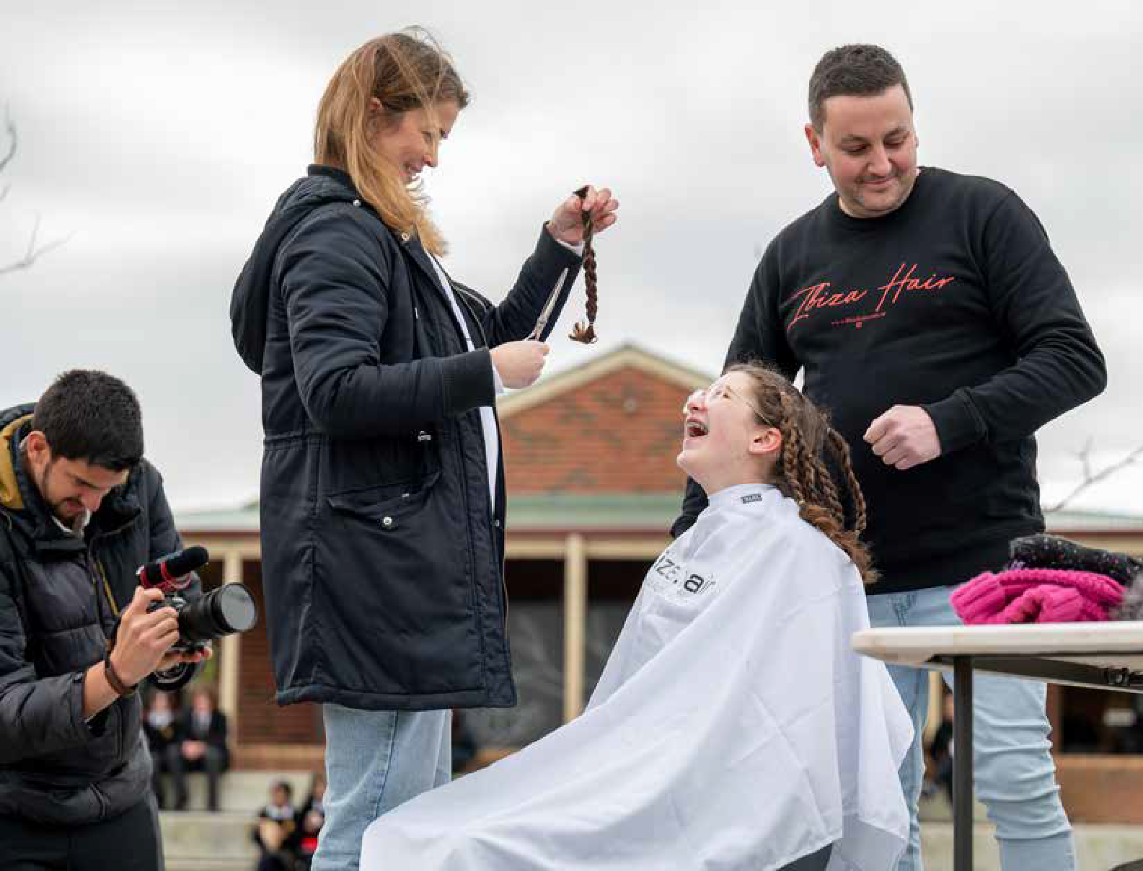

11

CONTACT US

CREST EDUCATION
500 Soldiers Road Clyde North
Ph. 9702 2144 (HCC)
Ph. 9703 9777 (RCC)
email: admin@cresteducation.vic.edu.au www.cresteducation.vic.edu.au

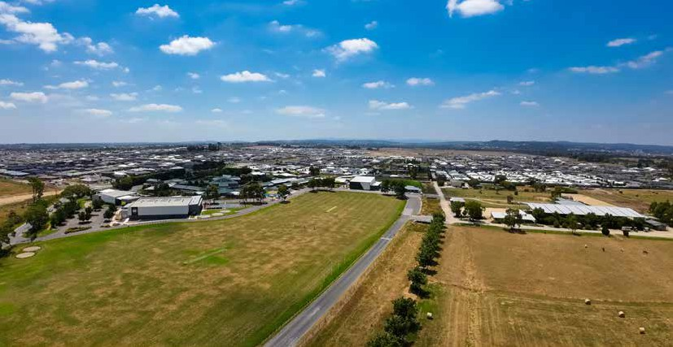
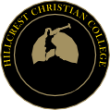


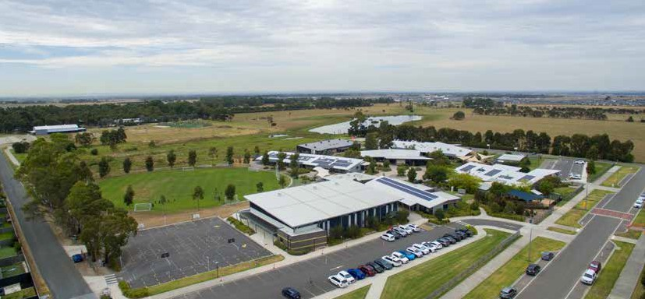

CHILD SAFE STATEMENT
CREST has zero tolerance for child abuse and is committed to providing a child safe
environment where children and young people are safe and feel safe, and their voices are heard about decisions that affect their lives.

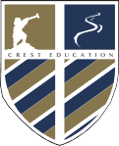
VISION

CREST Education is a leading provider of quality Christian education to the Casey and Cardinia communities of South East Melbourne. Our magnificent 138 acre property serves as a precinct for two Colleges, Hillcrest and Rivercrest, an Equestrian Centre, Agriculture/Horticulture precinct and Environmental Centre with a significant area set aside for waterways, and reclaimed bush bordering Cardinia Creek.
To be a leading provider of quality Christian Education, delivered by Christian staff, equipping students for a life of faithful service.

